**5G Architecture**

5G systems includes 5G Core Network(CN), 5G Access Network(AN) and User Equipment(UE)

**5G Core Network(CN):** It provides connectivity to internet and to applications server.

**5G Access Network(AN):** It can be 3GPP Next Generation Radio Access network (NG RAN) or Non-3GPP Access network.

* 3GPP Next Generation Radio Access network (NG RAN) can be based upon of the following options..

1. Standalone New Radio (NR) Base station.
2. Standalone Long-Term Evolution (LTE) Base Station upgrade to allow connection to the 5G core Network.
3. Non-Standalone Base station using NR as the anchor and LTE as an extension.

A New Radio base station is known as gNB where as the LTE base station has been upgraded to allow connectivity with the 5G core network is known as enhance eNB or next generation eNB.

* Non-3GPP Access network can be

1. Non-3GPP Access network is wireless local area network (WLAN) based upon Wi-fi
2. Non-3GPP Access networks use a Non-3GPP interworking Function (N3IWF) to allow connectivity with 5G Core Network.
3. N3IWF supports 3GPP interfaces towards the 5G Core Network and Non-3GPP interfaces towards the 5G Core Network and Non-3GPP interfaces towards the non-3GPP Access Network.

There are two types of architecture we define in a 5G Core network:

1. Reference Point Representation
2. Service based Architecture.

Between a network function there would be an interface (N22)

**NG RAN:** This is next generation radio access network. Where’s a typically device which is gNB.

<https://www.rfwireless-world.com/Terminology/5G-AMF-UPF-SMF-PCF-UDM-functions.html>

A gNB (gNodeB) is a node in a cellular network that provides connectivity between user equipment (UE) and the evolved packet core (EPC). A gNodeB is the functional equivalent of a base station in a traditional cellular network.

A gNodeB is responsible for radio communication with UEs in its coverage area, known as a cell. A gNodeB may be a physical entity, such as a tower, or it may be a virtual entity, such as a software defined radio (SDR).

A gNodeB has a number of functions, which include:

Radio resource management

Mobility management

Connection management

Security

Quality of service (QoS)

Charging

**UPF:** User plane function. Above from UPF it is Control plain(CD) and Signaling. Blow we have User plane(UP) or traffic.

The UPF is one of the central elements of a 3GPP 5G core system architecture. It is a primary network function (NF) of the 5G core network (5GC) and plays the most critical role in data transfer. It interconnects the Data Network (DN) in the 5G architecture. It is also responsible for packet routing and forwarding, packet inspections, QoS (Quality of Service) handling, and an anchor point for intra & inter RAT mobility, with new functions on the horizon.

UPF is a Virtual Network Function (VNF) that offers a high-performance forwarding engine for user traffic. It uses Vector Packet Processing (VPP) technology to achieve ultra-fast packet forwarding while retaining compatibility with all the user plane functionality. This allows packet processing and traffic aggregation to be performed closer to the network edge, making UPF the prime enabler of new 5G applications and customer-specific edge services.

<https://telecompedia.net/5g-core-network-overview/>

This is service based architecture where every interface creates like Restful API (Application programming interface). When you want to contact with network interface then you have to go through API and for this we will use HTTP2 protocol. In HTTP2 we will use serialization protocol JSON (Java script object notation).

**Control Plane:** will manage singnalling

**User Plane:** Here only UPF which connect with external Data network. Before we used PDN now DN.

* Understand Architecture.
* Available Opensource tools: NS3, NS2
* Implementation for virtualization Docker or VM
* gNB and UE possible
* What is next step???

***# 5G Reference point Architecture***

A reference point representation, shows the interaction exist between network elements by point-to-point reference point. It is like a point-point interface between two network elements e.g. N11 interface between AMF and SMF. In reference point system architecture, the interface names are labeled like: N5, N7, N8 etc.

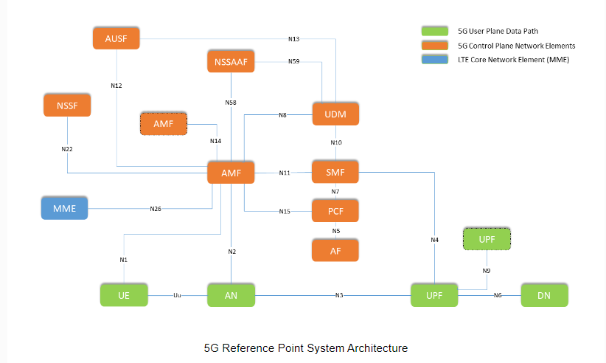

Interface Names in Reference Point Architecture

The 5G System Architecture contains the following reference points:

N1: Reference point between the UE and the AMF.

N2: Reference point between the (R)AN and the AMF.

N3: Reference point between the (R)AN and the UPF.

N4: Reference point between the SMF and the UPF.

N6: Reference point between the UPF and a Data Network.

N9: Reference point between two UPFs.

N5: Reference point between the PCF and an AF.

N7: Reference point between the SMF and the PCF.

N8: Reference point between the UDM and the AMF.

N10: Reference point between the UDM and the SMF.

N11: Reference point between the AMF and the SMF.

N12: Reference point between AMF and AUSF.

N13: Reference point between the UDM and Authentication Server function the AUSF.

N14: Reference point between two AMFs.

N15: Reference point between the PCF and the AMF

N16: Reference point between two SMFs

N16a: Reference point between SMF and I-SMF.

N17: Reference point between AMF and 5G-EIR.

N18: Reference point between any NF and UDSF.

N19: Reference point between two PSA UPFs for 5G LAN-type service.

N22: Reference point between AMF and NSSF.

N23: Reference point between PCF and NWDAF.

N24: Reference point between the PCF in the visited network and the PCF in the home network.

N26: Reference point between AMF and MME

N27: Reference point between NRF in the visited network and the NRF in the home network.

N28: Reference point between PCF and CHF.

N29: Reference point between NEF and SMF.

N30: Reference point between PCF and NEF.

N31: Reference point between the NSSF in the visited network and the NSSF in the home network.

N32: Reference point between SEPP in the visited network and the SEPP in the home network.

N33: Reference point between NEF and AF.

N34: Reference point between NSSF and NWDAF.

N35: Reference point between UDM and UDR.

N36: Reference point between PCF and UDR.

N37: Reference point between NEF and UDR.

N38: Reference point between I-SMFs.

N40: Reference point between SMF and the CHF.

N50: Reference point between AMF and the CBCF.

N51: Reference point between AMF and NEF.

N52: Reference point between NEF and UDM.

N55: Reference point between AMF and the UCMF.

N56: Reference point between NEF and the UCMF.

N57: Reference point between AF and the UCMF.

N58: Reference point between AMF and the NSSAAF.

N59: Reference point between UDM and the NSSAAF.

***# 5G Service based Architecture:***

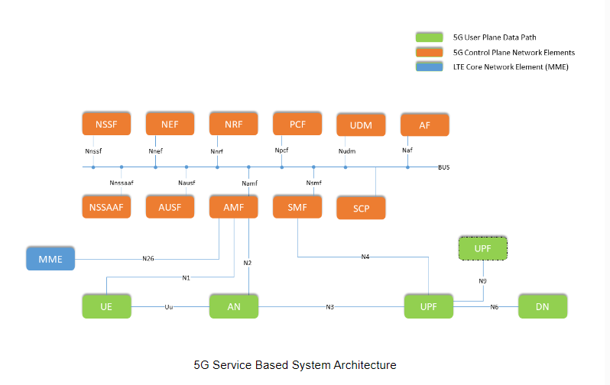

Interface Names in Service Based Architecture

Namf: Service-based interface exhibited by AMF.

Nsmf: Service-based interface exhibited by SMF.

Nnef: Service-based interface exhibited by NEF.

Npcf: Service-based interface exhibited by PCF.

Nudm: Service-based interface exhibited by UDM.

Naf: Service-based interface exhibited by AF.

Nnrf: Service-based interface exhibited by NRF.

Nnssaaf: Service-based interface exhibited by NSSAAF.

Nnssf: Service-based interface exhibited by NSSF.

Nausf: Service-based interface exhibited by AUSF.

Nudr: Service-based interface exhibited by UDR.

Nudsf: Service-based interface exhibited by UDSF.

N5g-eir: Service-based interface exhibited by 5G-EIR.

Nnwdaf: Service-based interface exhibited by NWDAF.

Nchf: Service-based interface exhibited by CHF.

Nucmf: Service-based interface exhibited by UCMF.

**Authentication Server Function (AUSF)** is responsible to handle authentication requests for both, 3GPP access and untrusted non-3GPP access.

**Access and Mobility Management Function (AMF)** has huge number of responsibilities, but below ones are some of them:

1. Registration management.
2. Connection management.
3. Reachability management.
4. Mobility Management.
5. Access Authentication.
6. Access Authorization.

**Unstructured Data Storage Function (UDSF)** is introduced to store dynamic state data (e.g. UE-related data, context can be stored in a central UDSF and multiple AMF can reach this context anytime to handle the procedure for seamless continuation of services in case of serving AMF experience outage). Network functions may have their own UDSF or it can be common. Here structured data refers to data for which the structure is defined in 3GPP specifications and unstructured data refers to data for which the structure is not defined in 3GPP specifications.

**Network Exposure Function (NEF)** The Network Exposure Function (NEF) is a functional element that supports the following functionalities:

Securely exposes network capabilities and events provided by 3GPP Network Functions to AF.

Provides a means for the AF to securely provide information to 3GPP network and may authenticate, authorize, and assist in throttling the AF.

Translates the information received from the AF to the one sent to internal 3GPP NFs, and vice versa.

Supports to expose information (collected from other 3GPP NFs) to the AF.

**Network Repository Function (NRF)** is used for service discovering of network functions or simply say it allows every network function to discover the service list offered by other network functions.

**Network Slice Specific Authentication and Authorization Function (NSSAAF)** supports Network Slice-Specific Authentication and Authorization with a AAA Server (AAA-S). If the AAA-S belongs to a third party, the NSSAAF may contact the AAA-S via a AAA proxy (AAA-P).

**Network Slice Selection Function (NSSF)** is a control plane function within 5G core network and supports below functions for network slicing:

1. Selecting the set of Network Slice instances serving the UE
2. Determining the Allowed NSSAI and, if needed, the mapping to the Subscribed S-NSSAIs
3. Determining the Configured NSSAI and, if needed, the mapping to the Subscribed S-NSSAIs
4. Determining the AMF Set to be used to serve the UE, or, based on configuration, a list of candidate AMF(s), possibly by querying the NRF.

**Policy Control Function (PCF)** provides policy rules to Control Plane functions (e.g. AMF) to enforce them, accesses subscription information relevant for policy decisions in a Unified Data Repository (UDR).

**Session Management Function (SMF)** includes the following functionality:

1. Session Management e.g. Session Establishment, modify and release, including tunnel maintain between UPF and AN node.
2. UE IP address allocation & management.
3. DHCPv4 (server and client) and DHCPv6 (server and client) functions.
4. Downlink Data Notification.
5. Support P-CSCF discovery for IMS services.

**Unified Data Management (UDM)** is a control plane function of 5G core network, it is similar HSS in 4G network. It has following functionalities: subscription management, SMS management, storage and management of SUPI for each subscriber in the 5G system. Here SUPI is “Each subscriber in the 5G System shall be allocated one 5G Subscription Permanent Identifier (SUPI) for use within the 3GPP system. The 5G System supports identification of subscriptions independently of identification of the user equipment. Each UE accessing the 5G System shall be assigned a Permanent Equipment Identifier (PEI)”

**Unified Data Repository (UDR)** is another type of storage which stores data belongs to UDM, PCF or NEF and others. It can be dedicated for a network function (e.g. only for UDM) or can be shared between multiple network functions. UDR has following functions:

1. Storage and retrieval of subscription data by the UDM.
2. Storage and retrieval of policy data by the PCF.
3. Storage and retrieval of structured data for exposure.

**UPF: User plane function.** Above from UPF it is Control plain(CD) and Signaling. Blow we have User plane(UP) or traffic.

The UPF is one of the central elements of a 3GPP 5G core system architecture. It is a primary network function (NF) of the 5G core network (5GC) and plays the most critical role in data transfer. It interconnects the Data Network (DN) in the 5G architecture. It is also responsible for packet routing and forwarding, packet inspections, QoS (Quality of Service) handling, and an anchor point for intra & inter RAT mobility, with new functions on the horizon.

UPF is a Virtual Network Function (VNF) that offers a high-performance forwarding engine for user traffic. It uses Vector Packet Processing (VPP) technology to achieve ultra-fast packet forwarding while retaining compatibility with all the user plane functionality. This allows packet processing and traffic aggregation to be performed closer to the network edge, making UPF the prime enabler of new 5G applications and customer-specific edge services.

**Application function (AF)** which support application .

AF stands for Application Function. Following are the functions of 5G NR AF node.

• Application influence on traffic routing.

• Accessing Network Exposure Function.

• Interacting with the Policy framework for policy control.

**Network Data Analytics Function (NWDAF)** represents operator managed network analytics logical function. The NWDAF includes the following functionality:

1. Support data collection from NFs and AFs.
2. Support data collection from OAM.
3. Support analytics information provisioning to NFs, AF.

**CHarging Function (CHF)** is not described in this page, you can find specifications in 3GPP TS 32.240.

**Service Communication Proxy (SCP)** has following functionalities:

1. Message forwarding and routing to destination NF/NF service.
2. Message forwarding and routing to a next hop SCP.
3. Indirect Communication, let’s have a bit more information for this function.